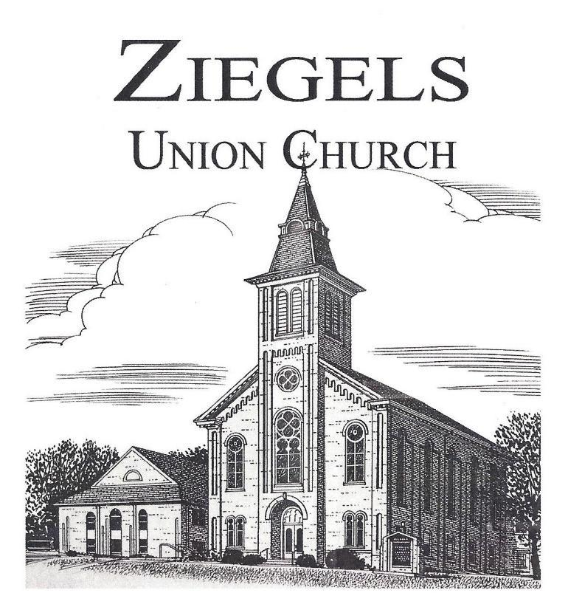
9990 Ziegels Church Road, Breinigsville, PA 18031

May 2024
NEWSLETTER
Sponsored by: Men’s Bible Study
Volume 24, Issue 5

Please worship with us each Sunday!
UCC Worship: 8:30am Lutheran Worship: 11:05am
Sunday School: 10:00am

A Big “Thank You” to the May Website Sponsors:
Harry & Bonnie Millward
In honor of Memorial Day, the office will be closed Monday, May 27, 2024.

NEWSLETTER MAILING
To save postage costs, both congregations are asking members to notify the office if you would like to be taken off the newsletter mailing list. If you prefer not to receive a printed newsletter, it can be read electronically by going to our website www.ziegelschurch.org and clicking on the newsletter link. You can also provide an email address if you prefer electronic communications. Call Laura (UCC) or Nicole (Lutheran) at 610-285-6157.
REMINDER!
The deadline for submissions for the June 2024 newsletter is Monday, May 20, 2024. Please contact the office with submissions.

Abbreviated Service Announcement
On Sunday, May 5th, – the UCC worship will be held in the Fellowship Room beginning at 8:30 am. This will be an abbreviated service (we will not have communion) to allow conversation and dialogue about the future of Ziegel's UCC.
Please plan to join us - we need you, and we need your voice. Materials regarding Consistory’s work over the past few months with a pastoral coach were mailed to UCC members. If you did not receive this information, please contact the office at 610-285-6157.

BREAKFAST!!! A continental breakfast will be provided. You may scan the QR code to guide you to the Sign-up Genius or visit: www.signupgenius.com/go/70A0D4DAAAD2AA5F49-49204215-ucccontinental#/ to sign up to bring items.

MAY MEETINGS
Committee Meetings
May 7th Union Committee Meeting 7:30pm
May 13th Lutheran Council Meeting 7:30pm
May 14th UCC Consistory Meeting 7:00pm
May 21st Property Committee Meeting 7:00pm
June 5th Office staff (via Zoom)
Weekly Events
Monday AA 7:30pm
Tuesday Cub Scout Pack 61 6:30pm
Wednesday Cadette Girl Scout Troop 68 6:30pm (2nd & 4th Wed)
Thursday Handbells 6:00pm & Senior Choir 7:15pm
Friday Men's Prayer Breakfast 7:00am at Cracker Barrel

MEN’S BIBLE STUDY BREAKFAST meets every Friday at 7:00am at the Cracker Barrel in Fogelsville. All are welcome to enjoy breakfast and study the weekly scriptures. Please contact the church office for the Men’s Bible Study leader’s contact information.
Cadette Girl Scout Troop #68 contact Beth Furman at 484-217-2197 for details.
Cub Scout Troop #61 contact Rick Sherer at 484-357-5430 for details.

SPONSORS NEEDED!
Please consider signing up to financially contribute in some small way. It’s a wonderful way to remember or honor a loved one and a means to financially support the missions of our congregations. Sign-up sheets are in the narthex, or you can contact the individuals below:
Altar Flowers and Piano Vases-
- Lutheran - Contact Gloria Hausman at 610-285-6741
- UCC - Contact Laura Loch at 610-285-6157
Bulletins - $20 per week
- Lutheran - Contact Sandy Rothermel at 484-824-3237 or Sandyravon@aol.com
- UCC - Contact Laura Loch at 610-285-6157
Monthly Newsletter - $40 per month; contact church office
Website - $30 per month; contact church office
Food Pantry Sponsor - $70 per month or $35 for ½ month

UNION COMMITTEES, MINISTRIES & MISSIONS
CHRISTIAN EDUCATION
- Vacation Bible School: June 17th-21st
- Confirmation: November 3rd

Early Communion Classes
The Sunday School will be offering Early Communion classes for students on May 5th and 12th. Classes will be held during the Sunday School hour and will be led by Pastor Andy and Pastor Larry in the Hebrews Room. Students who complete the classes will receive their First Communion on Sunday, May 19th. Please contact the Sunday School office for more information at ziegelsce@gmail.com.

Vacation Bible School 2024 – ”Start the Party”
It’s Time to Celebrate…
So, paint some signs, decorate the walls, hang the lights, turn up the music, invite some friends, and throw open the doors. We don’t think it’s just ok to have fun; we think it should be a priority. Why? Because people who follow Jesus have a lot to celebrate. Jesus gives us some pretty good reasons to party. Friendship, belonging, forgiveness, abundant life, and purpose. That’s why we believe the Gospel of Jesus is the good news. Since there seems to be a lot of bad news going around today, we have an incredible opportunity to remind this generation why Jesus is good news. We can create an environment where faith can be exciting, adventurous, fun, interesting, challenging, and engaging.

So…let’s Start the Party.
VBS 2024 will be held the week of June 17th-21st from 9 am to 12 pm. Kids aged 3 (by June 1st ) through 6th Grade are invited to our party! Adult and teen helpers are always welcome!
Registration forms are available outside of the Sunday School Office or in the church office. Contact Kristin Folck at ziegelsce@gmail.com for more information.

VBS Snack Donations
During our week of fun, we provide delicious snacks for our partygoers. The following items are needed and can be placed in the kitchen marked VBS by June 16th. Thank you!
3 family sized boxes of Nilla wafers | 2 family size boxes of Goldfish | 2 large boxes of animal crackers
2 lbs. grapes | 4 lbs. strawberries | 3 bags of oranges
3 bags of pretzel sticks | 2 bags of cheese balls | 2-48 count boxes of fruit snacks

Ziegels Handmade Market
Ziegels Christian Education is excited to announce our very first Handmade Market. Interested in showcasing your items?
On November 16th, from 10 am to 3 pm, our craft market will showcase vendors selling handmade needle crafts, sewn creations, jewelry & more! Each vendor will be donating a basket to our charity raffles. There will be food available and a bake sale, too! A special young crafter area will be available for our young people to showcase and sell their crafts! Contact the CE Team at ziegelsce@gmail.com.

Contact our Director of CE, Kristin Folck or our SS Officers (Laurie Rex or Kelly Lucarelli) if you need more info at ziegelsce@gmail.com. You can also find us in the CE office on Sunday mornings!

WORSHIP & MUSIC
*Senior Choir meets on Thursday evenings at 7:15pm.
*Handbell Choir meets on Thursday evenings at 6:00pm.
*Youth Chimes meets on Sunday mornings from 9:30am- 10:00am.
Parents, do you have children interested in singing or playing chimes? We would love to see an active youth choir! Come out for fun, fellowship, and learning new musical skills. Contact Jill at jillbb22@gmail.com or 484-456-6701 if you wish to join any of the choirs or would like more information.
SEWING MISSION
The team meets on the 4th Tuesday of each month at 5:30pm to sew pillowcases for local children’s hospitals, dresses for “Dress A Girl Around the World,” and chemo port cushions. For information, contact Shelley Daniels at 610-704-4500 or email seashell246@gmail.com.

HAND QUILTING
This group meets every Monday from 9:00am-12:00pm.
For information, please contact Michele Quier at 484-661-6049.

PRAYER SHAWL MINISTRY
Meetings are the 3rd Wednesday of each month at 9:00am in the Fellowship room to crochet prayer shawls and knit baby blankets. Members are willing to teach if you want to learn a new skill! Contact Gloria Hausman at 610-285-6741 for information.

FELLOWSHIP COMMITTEE
This committee plans special events for the church and meets the third Sunday of each month at 10:00am in the Fellowship hall.
If you would like to help in any way, contact Carley or Shana at ziegelsfellowship@gmail.com.

Annual Yard Sale: On May 25th, from 8 am to 1 pm, will be the annual yard sale. All money raised will support Wreaths Across America. If you would like to reserve a spot, please email ziegelsfellowship@gmail.com. If you are a member, spots are free. Non-members’ cost is $10. If you are not interested in selling your items, but you have items that you’d like to donate to the church table, please place them in the church history room, clearly labeled “Yard Sale”. We will be having the concession stand open during the yard sale. If you’d like to donate anything, please use the QR code which will direct you to the sign-up genius link. Thank you in advance!
JOIN US FOR BRUNCH!!! On June 30th, the Fellowship Committee is hosting a potluck brunch in the grove following the outdoor union service at 9 am. We ask you to bring your favorite breakfast brunch item to share with the congregation. After brunch, we will play bingo and yard games. Please consider donating small bingo prizes, and we encourage you to be creative. Some fun ideas could be plants, vegetables, small gift cards, baked goods, etc.

SUNDAY FELLOWSHIP HOUR
Please join us for fellowship & refreshments after the 8:30am worship service every Sunday. Volunteers are needed to help set-up, clean-up, and supply refreshments to continue this mission in 2024. There is a sign-up sheet located in the Fellowship room or contact Doreen Wynn at 610-481-0143 or luvplumeria@yahoo.com.

HISTORY COMMITTEE
If you are interested in our church history and would like to learn more or volunteer to help with this committee, please contact Mary Redline by phone at 610-395-8241 or discerepa@aol.com.

PRAYER MINISTRY
Are you interested in being a prayer warrior for Ziegels members and our community? Please reach out to the church office or contact Kelly at kellylucarelli@yahoo.com or 484-375-8978.

TECHNOLOGY COMMITTEE
If you have any questions, please talk to Michael Longenderfer at mlong75@ptd.net or Winona Schappell at wnschappell@gmail.com.
QR Code Training
On May 12th at 9:45am there will be a QR code training that will last approximately 15-20 min. Please join us in the Fellowship hall if you are interested in learning more.

LOWHILL FOOD PANTRY: MARCH STATISTICS
May Sponsors:
Bob & Jane Mason

- 68 family units served (101 adults 76 children, 40 seniors) for a total of 217 individual clients served.
- Breakdown of serving: 23 families on Saturday, 25 families on Wednesday, 20 families on Thursday with no emergencies need this month.
- 66 children served through the Weekend Children’s program.
- Ziegels Union Church donated 123 pounds of food this month, along with many needed items for the Blessings Room.

CURRENT FOOD NEEDS: Cereal, jelly, ketchup, canned milk, and some cleaning supplies (floor cleaner, toilet bowl cleaner, and dish detergent).
CURRENT NEEDS FOR BLESSINGS ROOM: socks for all ages.
May 2024 servings: Saturday May 4th, Wednesday May 15th, and Thursday May 16th.

We Thank You for all your support and giving to this program.

If you wish to volunteer at the Food Pantry to help serve or stock, contact Marci at Lowhillfoodpantry@gmail.com Dates and times of volunteer opportunities are available on the Lowhill Food Pantry website calendar: www.lowhillfoodpantry.com Our mailing address is: Lowhill Food Pantry, P.O. Box 115, New Tripoli, PA 18066.

*What’s Happening Around Our Community*
Help support your local Weisenberg Volunteer Fire Dept! Offering 7 kinds of hoagies to choose from: Italian w/hot peppers and onions, Italian with no onions, Italian with no peppers, Italian with no peppers or onions, ham & American cheese, turkey, roast beef, and tuna salad. Cost is $7.00. Call Emma at 484-357-8827 to order. Pay at pick up on the 1st Thursday of each month from 2:30pm-6:00pm.
We would like to encourage everyone to visit https://nepasynod.org/e-news/ weekly to view what it is happening around our community. There are so many events posted that we could help support simply by attending and sharing with our friends, families, and neighbors.

BEAR CREEK CAMP
Registration is open for Bear Creek Camp’s overnight program which is centered on spiritual growth, outdoor living, and small group development for all children who have completed grades 1st-12th. Each age group experiences a mix of small-group and all-camp activities throughout the week to meet their group’s spiritual, social, and developmental needs. Bear Creek Camp is in Wilkes-Barre, PA. Register at BearCreekCamp.org. Please see the website for session dates.
Join in for an open house day at Bear Creek Camp, Saturday, May 4th from 11am-3pm. Explore camp, meet staff, boat, hike, craft, and fellowship with our camp community. Cookout lunch is available to all and there is no cost. Registration for May Play Day is available at https://bearcreekcamp.org/mayplayday/.

Mark Your Calendars!
Blessing of the Bikes: May 4th, 8am
Bear Creek Camp Open House: May 4th (see above for details).
Community Yard Sale: May 25th, 8am-1pm
50th Anniversary Walk for Hunger: June 22nd,
(Conrad Weiser High School, Robesonia, PA) 9am-1pm
Spring Brunch Picnic: June 30th
(Union worship at 9am, Brunch begins at 10am)
Ziegels Annual Tractor Show: July 13th, 3pm-7pm
Harvest Moon Festival: September 14th, 4pm -7pm
Ziegels Handmade Market: November 16th, 10am-3pm
Ziegels Union Church 275th Anniversary Celebration: Fall 2025-stay tuned for more information to come.
2024 Ziegels Church Leadership
2024 Lutheran Council 2024 UCC Consistory
Keith Harwick, President Kim Anderson, President
Ken Highley, Vice President Rob Ziegler, Vice President
Bonnie Millward, Secretary Rocky Redline, Secretary
Kelly Lucarelli, Treasurer Joyce Weishaupt, Treasurer
Dave Grillo Casi Gross, Asst. Treasurer
Michael Longenderfer Barbara Ziegler
Deanna Quay Laurie Rex
Winona Schappell Bob Lilley
Arlene Inman
2024 Union Committee Members
Robert Ziegler, President
Micheal Longenderfer, Vice President
Kerry Merkel, Treasurer

OUR STAFF & LEADERS
Rev. Andy Meckstroth, Lutheran Pastor 484-523-3039
Rev. Larry Pickens, Designated UCC Pastor 847-687-5897
Karly Rex, Sexton 484-513-0988
Jill Bruckart, Director of Music Ministries 484-456-6701
Kristin Folck, Christian Education Director 484-860-2549
Rob Ziegler, 2024 Union Church Pres. 484-333-0601
Keith Harwick, 2024 Lutheran Council Pres. 610-756-4308
Kim Anderson, 2024 UCC Consistory Pres. 484-951-2198
Nicole Wischner, Lutheran Secretary 610-285-6157
Laura Loch, UCC Secretary 610-285-6157

PASTORAL REQUESTS & EMERGENCY HOSPITALIZATIONS
If you or a family member is in need of pastoral care or have been hospitalized, you can contact the Pastors directly or use the Pastoral Care form found on our website www.ziegelschurch.org and click on the Pastoral Care link/doc at the top of the website page.

Church Office Hours: Monday-Friday 10:00am - 12:00pm
9990 Ziegels Church Road, Breinigsville, PA 18031
Phone: 610-285-6157

Union Church email: ziegelschurch@gmail.com
Lutheran Congregation email: lutheranziegels@gmail.com
UCC Congregation email: ziegelsucc@gmail.com
Christian Education email: ziegelsce@gmail.com
Fellowship Committee email: ziegelsfellowship@gmail.com

Ziegels Union Church Website: www.ziegelschurch.org

Find us on Facebook:
@Ziegels Union Church
@Ziegels Christian Education

May 2024 Prayer List
(as of April 29, 2024)
Please remember the following persons in your prayers.
A card or note of cheer would be greatly appreciated.

Member and Friends
George Windish Lori Brawn
Loretta Marsteller Sherri Lauer
JR Marsteller Marlene Evangelista
Megan Koch Molly Hanna
Phil Cardinale Steve Colsten
Barry Brobst Tim Kleinsmith
Connie Davis Tommy Inman, Jr.
Maynard Koplin Keith Quier
Laurie Grammes Linda Folck
James Fritch Rosie Zekany
Judy Whiteside Baby Lucy
Steve Haas Brian Wynn
David Krause
Members and Friends in the Military
U.S. Army: Garth Ritter, Jessica Albright Thomas, Scott Esterly, Chris Owens, and Connor Smith
U.S. Air Force Academy: Josh Wynn
U.S. Navy: Ben Beitler
Air Force Reserves: Dale Host

Nursing home, Assisted living, & Home bound
Gloria Herber Al Savelli
Robert Henninger Arlene George
Laila Loch Clarabelle Dengler
Mae Fitzgerald Nancy Kleinsmith
Betty Lotier Eldred Snyder
AJ Henry Ann Raubenhold

Help to keep this list current by reviewing it and updating the office staff, Pastors, and/or Kelly Lucarelli, with their status and progress. We will remove names appearing for 4 weeks or more unless otherwise advised.

